Et388 program download instructions

1 Configuration
Data cable: Android data cable
Terminal equipment: ET380B
PC tool: MFToolSetA.exe (used to download programs and data)

2 Driver Installation

2.1 Double-click to run the automatic installation script in the driver installation package to install

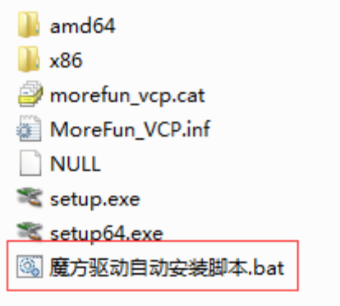

2.2 Driver installation complete

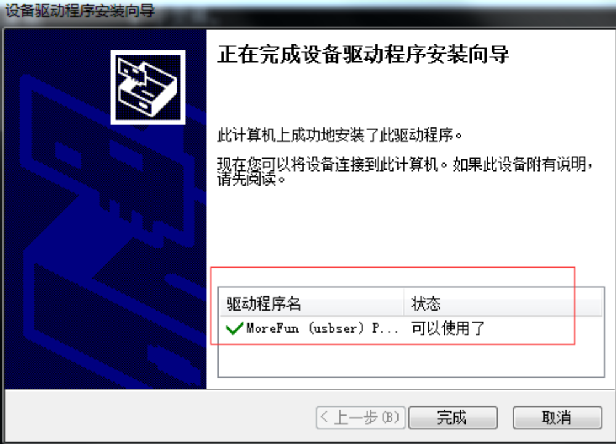

3 Data download
3.1 Press the power on button to turn on the terminal。
3.2 Use the data cable to connect the terminal and PC, open the PC device manager, and check the port number of the communication between the terminal and PC.
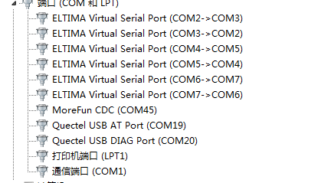

4 PC operation
1，Run the download tool MFToolSetA.exe
2，Select data download, click set button and select data file (. Bin)
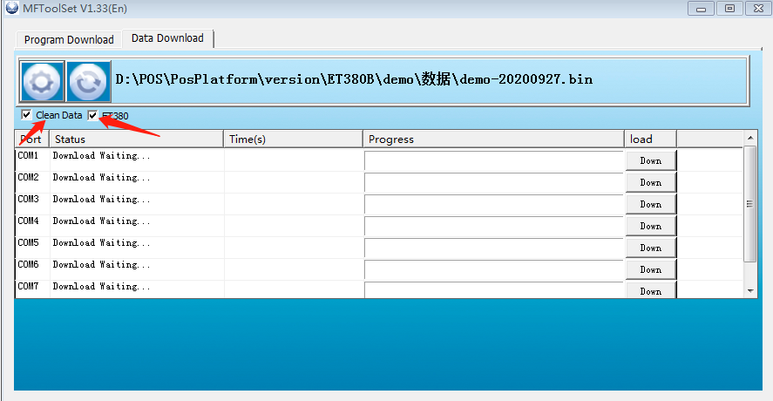
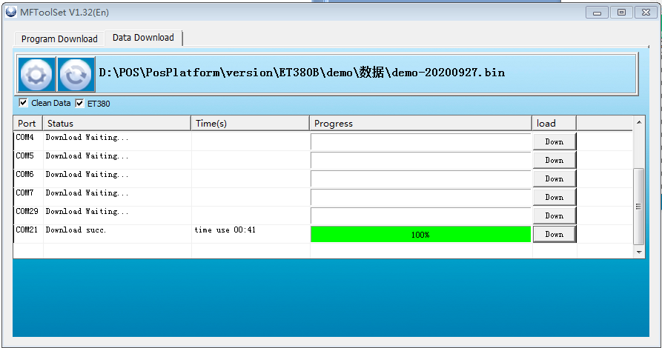

4，After the data download, wait for the terminal to restart automatically (Note: data decompression takes about 3 minutes, please do not restart manually)。

